

The University of Edinburgh

School of Mathematics

Topics in Applied Operational Research

Instructor: Professor Miguel Anjos

Group members:

Siyu Wang (s1920930)

Sijing Wu (s1994311)

Shuai Pan (s1925253)

DATE: 27/02/2020

**1 General Introduction**

**1.1 Background**

Webb Wheel (WW) is an auto parts manufacture, which services the commercial vehicle aftermarket at the Mississippi River via two plants. It receives new orders from customers each day. Considering sufficient inventory, WW combines these orders into loads daily, and releases them based on different dispatch criteria, including truck-utilization and route-efficiency. For outbound shipments, WW has two delivery options, truckloads and containers. The company intends to improve its operational performance, so the main goal is to help the company decide the amount of customer orders shipping at both plants. And one of secondary goals is to characterize and evaluate load-dispatch polices. The main challenge, is dynamically changing and incomplete demand information. The research team has designed an integrated model to simultaneously optimize the loading and routing decisions. The optimization model is divided into assignment sub-problem and routing sub-problem.

**1.2 Transportation Mode Characteristics**

As we mention before, WW relies on common carriers that use TL and IM policies to fulfill customer orders. The more detailed specifics for these transportation modes are as follow:

1. Truckload (TL) Characteristics

The cost of a TL route is based on the distance travelled, the mileage rate and the number of drops on the route. Therefore, the total cost is determined in one of two ways: If minimum charge is met or if minimum charge is not met. Besides, we need to pay attention that the capacity of the trucks is limited and the mileage rate of the final drop location.

1. Intermodal (IM) Characteristics

This mode is cost saving as first load the order onto a container and then transport to a ramp; after that, the container is loaded onto another truck for delivery. There are two main costs: a drop charge per order and a ramp location-based fixed cost. We need to pay attention that the capacity of the trucks and total service time limits.

**2 Assignment Sub-problem Model**

The assignment sub-problem determines the choices of transportation mode and carrier, while considering the total transportation cost.

**2.1 Modelling Considerations**

Current practice is determined as follows: Select the farthest open order from the factory as benchmark, and then manually add other orders to the path until maximum capacity is reached. Using the algorithm, we will consider the TU rate and RU at the same time. We will consider due dates instead of considering a time as each order will be assigned to a route no matter the dates. In order to optimize the problem, we divide the overall problem into two sub-problems.

**2.2 Data Generating**

To generate the location of order, plant and seed, we make some assumptions.

(1) We used Ningbo city in Zhejiang province as the reference city. It is relatively squared, and the area is about 10000 $km^{2}$.

(2) We divided the total area into three main districts. Then, we assume that the order location follows Gaussian distribution in each district.

(3) The paper shows that the order number in four month is about 2300. Therefore, we set the order number to 100 per week.

(4) The plant is set up in remote suburbs of the city because of lower costs. So we set the plant at coordinate (10, 10) in the figure 1.

(5) The seed locations and container locations are selected based on order distribution and the distance between order locations and plant location. Since the container use train and can reduce the cost, we set each container location at the center of the two further districts.

(6) We assume that one seed location can serve only 20 customers. Therefore, we set the four seed locations and two container locations respectively.

To generate the order location, firstly, we chose three points, which represent the most popular districts. Then we add 10 times Gaussian noise to these three points. We also assume the point that is closest to the plant has more customers than other two points. Therefore, we generate 40 points to the closest point and 30 points to other 2 points separately. The figure of seed, plant and order locations can be seen below.

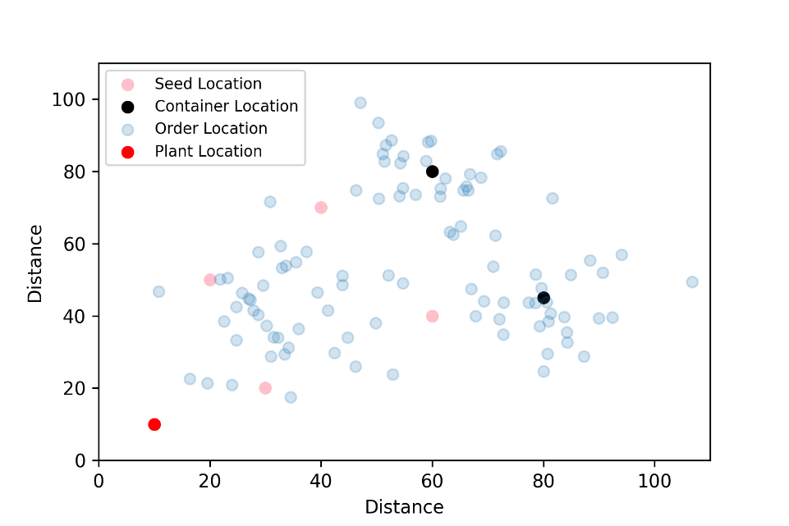

Fig 1. Scatter plot of seed location, order location and plant location

From this dataset, we calculated $d_{ij}$ the distance between seed locations to order locations, $d_{0j}$ the distance between plant to seed locations, and $d_{0j}$ the distance between plant and order location.

Other parameters selection is based on paper. We set rate per mile equal to 2.31 which is used by author. We set the weight of products between 60 and 120. The demand of each product from seed location to order location is randomly between 2 and 10. The capacity of each seed location is 0.2 million and the inventory of each product is set randomly between 575 and 655 which is get from the sum of demand. In order to mimic critical order, we assume the critical order follows binomial distribution with n = 100 and p = 0.2.

**2.3 Modelling Discussions**

**2.3.1 Dispatch Policies**

To determine which routes to dispatch, we evaluate three policies:

(1). Weight-based (TU) truck utilization;

$TU$ = $\frac{\% the total weight}{capacity}$

(2). Route-based (RU) utilization;

$$RU=\frac{\% total weight distance }{total ton miles available in the route }$$

**2.3.2 Assignment problem**

The objective is to minimize the sum of setup and connection costs without violating any of the location-related constraints. And we define seed sets for each transportation mode. Our model includes TL and IM polices. We assume that one seed location can serve 20 customers so as to determine the number of truck-seed location. Then we calculate truck-seed location costs according to the truck cost structure in the appendix.

Decision Variables: the model has been introduced three sets of decision variables. The first shows the setting of the seed location and checks whether it is used; the second is to assign customer orders to seed location; and the last one represents the quantity of products delivered to a customer via a selected seed location.

Constraints: Constraints (1) ensure that the capacity of a seed is not exceeded by weight-based products p shipped under any circumstances. Constraints (2) and constraints (3) state that the total amount of shipment through two transportation modes for a chosen product for a customer order is supposed to be less than the demand of orders and available inventory respectively. Constraints (4) ensure that the satisfying the demand for critical customer orders has been given priority when WW is confronted with inventory shortcomings. Constraint (5) states the amount of product *p* shipped for order *j* via seed location *i* need to equal or greater than the minimum between the sum of the demand and inventory, so order is be satisfied as much as possible. We use the star-distance approximation to estimate the total travel time of the loads and determine whether use this container seed. Constraint (6) ensure the sum of time spent during the delivery is less than or equal to the total service time, which means the order can be assigned to the container seed locations if this constrain holds.

Actual route Star-distance approximation

Fig 2. Star-distance approximation

Constraint (7) and (8) present the relationship among decision variables.

Results and Discussion

**Appendix**

Truck-Seed Location Cost

$$c_{i}=\left\{\begin{aligned}d_{0}sr+mc , ifd_{0i,}≤mc \\ \left(sr+r_{i}\right)d_{0i,} otherwise\end{aligned}\right.$$

Assignment Cost to a Truck Seed

$$a_{ij}=\left\{\begin{aligned}dct+\left(d_{0j+}d_{ji}\right)sr+mc-c_{i, }if\left(d_{0i+}d_{ji}\right)r_{i}≤mc \\ dct+\left(d_{0j+}d_{ji}\right)\left(sr+r_{i}\right)-c_{i}, otherwise\end{aligned}\right.$$

Objective Function of Assignment Problem

$$\min\left\{\sum_{i}{c_{i}γ_{i}+\sum_{i}{\sum_{j}{a_{ij}z_{ij}}}}\right\}$$

Constraints



$\sum_{jϵF}{\sum_{pϵP}{w_{p}}}X_{ijp}≤Q_{i}, ∀i ϵ{ F}^{’}∪F^{’’}$

$\sum_{iϵF}{X_{ijp}}≤D_{jp}, ∀j ϵ F and p ϵ P$

$\sum_{iϵF}{\sum_{jϵf}{X_{ijp}}}≤ I_{p} , ∀p ϵ P$

$\sum_{iϵF}{\sum_{jϵf}{X_{ijp}}}K_{j}≥min\left(\sum_{j}{D_{jp}}K_{j} ,I_{p}\right), ∀p ϵ P$

$\sum_{iϵF}{\sum_{jϵf}{X_{ijp}}}≥min\left(\sum_{j}{D_{jp}} ,I_{p}\right), ∀p ϵ P$

$\sum_{iϵF}{\left(DT+2\frac{d_{ij}}{v}\right)Z_{ij}≤HL, ∀i ϵ F^{’’}}$

$\sum_{iϵF}{X_{ijp}≤\sum_{pϵP}{D_{jp}}}$

$Z_{ij}≤Y_{i} ,$ $∀i ϵ F and j ϵ F$

$X_{ijp}ϵZ^{+}, Y_{i} and Z_{ij} ϵ \left\{0,1\right\} , ∀i ϵ F ,j ϵ F and p ϵ P$

Decision Variables

1. : *is_binary*: 1 if order j assigned to seed location I else 0

2. : *is_binary*: 1 if seed location j is created for order I else 0

3. : *is_binary*: 1 if seed location I is used else 0

Parameters

1. sr: Surcharge Rate

2. $d_{oi}$: The distance between plant to seed location *i*

3: mc: Minimum charge by company

4: $r_{i}$: Rate per mile for seed location *i*

5: $d_{ct}$: Drop charge

6: $d_{ij}$: Distance from order location *j* to seed location *i*

7. $w_{p}$: weight of product *p*

8. $X_{ijp}$: amount of product p shipped for order j via seed location *I*

9. : (assume all capacity is same) capacity of seed location *i*

10. : Demand of product *p* in order *j*

11. : Available inventory of product *p*

12. : *is_binary*: 1if order is critical else 0

13. HL: Total available driving time

14. DT: Drop time of an order

15. : distance between seed location I and order location j

16. v:average speed

**Reference**

Anon, 2014. An Integrated Load-Planning Algorithm for Outbound Logistics at Webb Wheel. *Interfaces*, 44(5), pp.480–497.